

Curriculum Design for Science and Maths Sub-Topics aligned to CBE Grade 10
Scheme of Work for

Subject: Physics
Strand / Topic: # and Name: Electricity and Magnetism
Sub-strand / Sub-Topic: # and Name: Introduction to Electronics
Author:Okello

Curriculum Design: The lesson/unit is designed for students to make sense of phenomena and/or design solutions to problems by engaging in student sense making

Learning Outcomes: What will the students know and be able to do by the end of the Unit? What are the key scientific principles/key concepts that we want students to learn in this unit?
1. Knowledge and Understanding
By the end of the sub-strand, the learner should be able to:

Define and explain the meaning of conductor, insulator, semiconductor, and superconductor, with everyday examples.

Describe the energy band theory and use it to differentiate between conductors, semiconductors, and insulators.

Explain the concepts of intrinsic and extrinsic semiconductors, including how doping changes conductivity.

Distinguish between n-type and p-type semiconductors, and describe their role in electronic devices.

Explain how temperature affects conductivity in conductors, semiconductors, and superconductors.

Identify and describe applications of conductors, semiconductors, insulators, and superconductors in daily life (e.g., solar panels, computer chips, household wiring, MRI machines).

2. Practical Skills
By the end of the sub-strand, the learner should be able to:

Investigate the electrical behaviour of materials such as metals, plastics, and semiconductors in simple circuits.

Draw and interpret energy band diagrams to explain conductivity.

Use simulations or experiments to observe the effect of temperature on conductors and semiconductors.

Record, analyse, and present findings through tables, sketches, and group presentations.

Research applications of semiconductors and superconductors from reliable print and digital sources (e.g., videos, online simulations, textbooks).

3. Attitudes and Values
By the end of the sub-strand, the learner should be able to:

Appreciate the importance of semiconductors and superconductors in advancing technology and solving real-world challenges (e.g., renewable energy, ICT, medical technology).

Demonstrate curiosity and critical thinking by asking questions and making predictions during investigations.

Work cooperatively in groups, respecting contributions of others while conducting experiments or presentations.

Show responsibility and safety consciousness while handling electrical apparatus and circuits.

Develop a sense of patriotism by connecting electronics to Kenya’s growth in ICT and renewable energy (e.g., solar electrification).

Chapter and/or Unit Criteria  Lessons and units designed so students make sense of a phenomenon-based storyline and/or design solutions to problems.  The design of this unit/chapter includes: | Use Khan or Rachel or Internet to help you identify useful tools  Provide Links to Supporting Documents Found on Rachel or Internet | SENSE-MAKING  - Providing strategies for ensuring student sense-making and/or problem-solving about each lesson.  - Which sense-making tools will you use with each of the lessons you are building into your plan? | FORMATIVE ASSESSMENT:  - Find sample assessments in Rachel or Khan to use.  - Embeds formative assessment opportunities throughout that evaluate student learning to inform instruction.  - Provides multiple opportunities for students to demonstrate their understanding the content and receive feedback
- THE PHENOMENON: Making sense of phenomena and/or designing solutions to a problem drive student learning.  - The phenomenon is current, relevant, real world that can be answered by using science principles, computational skills and/or engineering design solutions.  - The phenomenon is observable and interesting to students. Something they want to figure out.  - The phenomenon is framed as a Driving Question to be figured out in the series of evidence gathering activities  - Student questions and prior experiences related to the phenomenon or problem motivate sense-making and/or problem solving.  - Students show their initial thinking by drawing a model. | -Real-life materials: copper wire (conductor), glass (insulator), diode chip (semiconductor), liquid nitrogen demo (superconductor, if possible).  Phenomena and Driving Questions – Conductors, Insulators, Semiconductors, and Superconductors  - Electricity Flow in Household Wiring  - Phenomenon: Metals like copper carry electricity efficiently, while plastics and wood do not.  - Driving Question: Why do some materials conduct electricity while others do not, and how does this affect the safety and efficiency of household wiring?  - Solar Panels and Computer Chips  - Phenomenon: Semiconductors in solar cells and microchips control the flow of electricity.  - Driving Question: How do semiconductors allow us to control electrical current in devices like solar panels and computers?  - Doping Semiconductors  - Phenomenon: Adding small amounts of impurities (doping) changes the conductivity of semiconductors.  - Driving Question: How does modifying a semiconductor make it more suitable for electronic devices?  - Temperature Effects on Conductivity  - Phenomenon: Conductors become less efficient at higher temperatures, semiconductors more conductive, superconductors lose all resistance below critical temperatures.  - Driving Question: How does temperature affect the ability of materials to conduct electricity, and why are superconductors special?  - Superconductors in MRI Machines  - Phenomenon: Superconducting magnets produce strong magnetic fields without energy loss.  - Driving Question: How can superconductors create strong magnetic fields efficiently for medical and technological applications?  - Insulators in Daily Life  - Phenomenon: Plastic, rubber, and glass prevent unwanted current flow and protect users.  - Driving Question: Why are insulators important for safety in electrical devices and wiring?  - Kenya’s Renewable Energy Systems  - Phenomenon: Solar panels and ICT devices rely on semiconductors to generate and manage electricity.  - Driving Question: How do semiconductors and superconductors contribute to Kenya’s technological growth and renewable energy solutions? | -The teacher begins with a simple demo: connect a bulb using a copper wire (lights up) and a glass rod (doesn’t light). Ask: “Why does one allow current while the other blocks it?” Students brainstorm and group ideas under conductors vs. insulators.  -Teacher then provokes curiosity: “What if there is a material that sometimes conducts and sometimes doesn’t?” → introducing semiconductors. | -Learners write one example each of conductor, insulator, and what they think a semiconductor is.  -Class discussion question: “What might a superconductor do differently from the others?”  -Quick sketch: draw the circuit seen in the demo and label which part worked and which didn’t.
PREPARE A MODEL SCAFFOLD  - A place for students to draw, write, discuss their initial ideas about the phenomenon  - Driving Question Board as an option to collect students’ initial ideas and questions after they draw their initial model. | -YouTube (Energy Band Theory):Here  Teacher-prepared posters or slides of band structures.  Colored counters or beads for role-play of electrons moving across gaps. | -Teacher introduces band theory with diagrams:  - Conductor → overlapping bands.  - Semiconductor → small gap.  - Insulator → wide gap. | -Peer review of band diagrams: groups exchange sketches and check accuracy.  -Quick oral Q: “Which material has the smallest band gap? Largest?”
PLAN FOR DRAWING UPON STUDENTS’ PRIOR KNOWLEDGE  Includes suggestions for how to connect instruction to the students' home, neighborhood, community and/or culture as appropriate.  - Provides opportunities for students to connect their explanation of a phenomenon and/or their design solution to a problem to questions from their own experience. | -YouTube (Conductors & Insulators everyday life):Here  -Items around class: chalk, metallic ruler, plastic pen, rubber band. | -Learners recall primary school knowledge: copper conducts, rubber insulates. Teacher links to semiconductors, introducing them as “the materials inside chips and solar panels” that can act in between. | -Sorting activity: learners classify classroom objects into conductor, insulator, or unknown.  -Teacher asks: “Why is copper used in wires and not rubber?”
Chapter and/or Unit Criteria  Lessons and units designed so students make sense of a phenomenon-based storyline and/or design solutions to problems.  The design of this unit/chapter includes: | Use Khan, Rachel, SV for Teachers, LabXchange, or Internet to help you identify useful tools  Provide Links to Supporting Documents Found on Rachel or Internet | SENSE-MAKING  - Providing strategies for ensuring student sense-making and/or problem-solving about each lesson.  - Which sense-making tools will you use with each of the lessons you are building into your plan?  - Teacher moves | FORMATIVE ASSESSMENT:  - Find sample assessments in Rachel or Khan to use.  - Embeds formative assessment opportunities throughout that evaluate student learning to inform instruction.  - Provides multiple opportunities for students to demonstrate their understanding the content and receive feedback
LESSON SEQUENCE  - Give a general outline of the lessons that will be used to teach this topic | Lesson 1–2: Conductors, Insulators, Semiconductors.  Lesson 3: Intrinsic Semiconductors.  Lesson 4: Extrinsic (n-type & p-type).  Lesson 5: PhET simulation  Lesson 6: Superconductors Explained.  Lesson 7: Case studies: solar panels, microchips, superconducting magnets. | -Lesson Structure – Teacher Moves  - Prediction Stage  - Learners: Make predictions about how a material or device will behave (e.g., whether conductivity will increase or decrease).  - Teacher Moves: Prompt learners with guiding questions, encourage reasoning based on prior knowledge, and help them record predictions clearly.  - Evidence Stage (Experiment/Simulation/Video)  - Learners: Observe experiments, simulations, or videos showing the actual behavior of conductors, insulators, semiconductors, or superconductors.  - Teacher Moves: Demonstrate or facilitate experiments/simulations, highlight key observations, ensure safety, and ask learners to note evidence accurately.  - Discussion Stage  - Learners: Share observations, compare with predictions, and discuss discrepancies.  - Teacher Moves: Ask probing questions to guide reflection, clarify misconceptions, and ensure learners connect observations to scientific principles.  - Explanation Stage  - Learners: Formulate explanations linking evidence to scientific concepts (e.g., n-type and p-type semiconductors).  - Teacher Moves: Provide analogies (e.g., “party guests” analogy: extra electrons for n-type, holes for p-type), guide learners in connecting analogies to concepts, and help them refine models or diagrams.  - Model/Concept Refinement  - Learners: Update models or diagrams based on evidence and discussion.  - Teacher Moves: Encourage iterative refinement, check accuracy of representations, and reinforce links between observations, predictions, and explanations. | -Daily exit slip: “Today I learned …”  -Lesson 3: learners draw intrinsic semiconductor band diagram.  -Lesson 6: learners explain in words what happens to resistance in a superconductor.
- THE EVIDENCE GATHERED: What are the lessons you will use in your class to help your student collect evidence to answer the Driving Question/ figure out the phenomenon?  - Provides at least 4 opportunities to gather evidence through (readings, practicals, simulations, videos)  - The focus of each lesson is to support students in making sense of phenomena and/or designing solutions to the problems and prior student experiences.  - Each lesson builds on prior lessons by addressing questions raised in those lessons, cultivating new questions that build on what students figured out, or cultivating new questions from related phenomena.  - Provides strategies for linking student engagement across lessons (revisit the model and add to the model as evidence is gathered and students figure it out). | -Student notebooks with diagrams.  -Group charts of classification.  -Simulation screenshots.  -PhET Simulation: Band Structure and Temperature Effect  -YouTube: Conductors, Insulators and Semiconductors :Great visual explanation of the three material types.Here  -YouTube: Energy Band for Conductors, Semiconductors & Insulators — Clear diagram-based breakdown.Here  -Khan Academy: Semiconductors Introduction | -Class maintains a “What We Figured Out” wall chart updated after each lesson. Misconceptions are crossed out and new knowledge added, showing the learning journey.  - “What We Figured Out” Wall Chart  - Learner Action: Add new understanding after each lesson about conductors, semiconductors, insulators, n-type/p-type, and superconductors.  - Teacher Move: Guides corrections, highlights key relationships, and ensures misconceptions are addressed.  - Exit Tickets  - Learner Action: Answer short questions on doping, temperature effects, or material types.  - Teacher Move: Reviews responses, provides feedback, and adjusts upcoming lessons accordingly.  - Quick Concept Maps  - Learner Action: Draw connections among conductor, insulator, semiconductor, and superconductor.  - Teacher Move: Prompts refinement of relationships and addresses misconceptions.  - Practical Investigations (Simple Circuits)  - Learner Action: Test metals, plastics, and semiconductors in circuits; record observations.  - Teacher Move: Observes with checklist, ensures safety, and clarifies experimental steps.  - Energy Band Diagram Tasks  - Learner Action: Draw and interpret diagrams showing energy bands and conductivity differences.  - Teacher Move: Guides interpretation, asks probing questions, and corrects errors.  - Think–Pair–Share Discussions  - Learner Action: Discuss intrinsic/extrinsic semiconductors and temperature effects in pairs/small groups.  - Teacher Move: Circulates, probes reasoning, clarifies misconceptions, and facilitates whole-class synthesis.  - Short Group Research Presentations  - Learner Action: Research applications (solar panels, computer chips, MRI) and present findings.  - Teacher Move: Ensures use of reliable sources, provides feedback, and emphasizes real-world relevance and patriotism.  - Prediction–Observation–Explanation (POE)  - Learner Action: Predict effects of temperature on conductivity, observe through experiment/simulation, explain results.  - Teacher Move: Facilitates predictions, guides observations, clarifies misconceptions, and reinforces scientific reasoning.  - Reflection Journals  - Learner Action: Record what was learned and remaining questions weekly.  - Teacher Move: Reviews entries, tracks conceptual progress and attitudes, and provides individualized guidance.  - Peer Review  - Learner Action: Check peers’ diagrams, sketches, or reports against criteria.  - Teacher Move: Provides rubrics, moderates discussions, and ensures fairness and accuracy.  - Oral Questioning  - Learner Action: Answer reasoning questions on n-type/p-type, doping, energy bands, and material properties.  - Teacher Move: Uses open-ended questions, probes thinking, and corrects misunderstandings.  - Short Quizzes  - Learner Action: Complete brief checks on definitions, comparisons, and explanations.  Teacher Move: Marks quickly, identifies learners needing support, and groups them for reteaching or extension.  - Simulation-Based Tasks  - Learner Action: Use PhET or circuit simulators to test temperature and doping effects on conductivity and record findings.  - Teacher Move: Demonstrates tool usage, monitors accuracy of recordings, and asks reflective questions to link to real-life applications. | -Teacher rubric: assesses clarity of diagrams, accuracy of explanations, application link.  -Peer reviews of group posters.
PLAN FOR THE SUMMARY TABLE HERE  - Create the summary table template here which includes the lesson title, a description of what was learned, and a place to reflect on how the lesson helps to explain the phenomenon. | Activity What did I observe? What did I learn? How does this explain the phenomena?  Teacher’s printed summary template.  YouTube refresher video: Energy Band Theory Recap. Here  Summary table  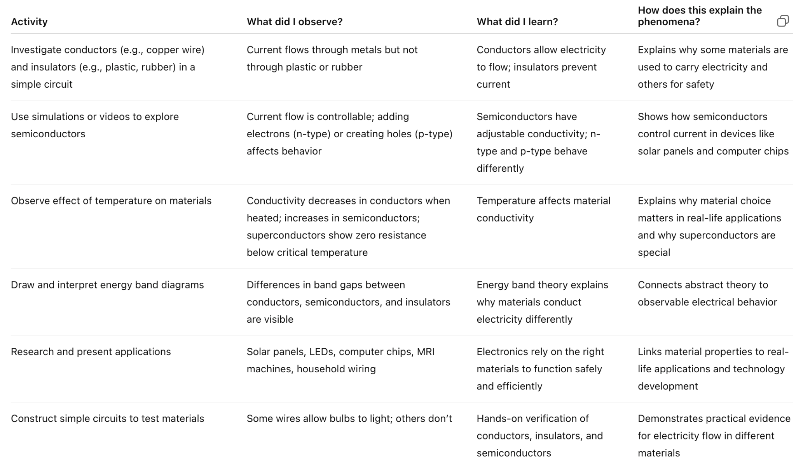 | -Learners collaboratively fill in a final comparison table:  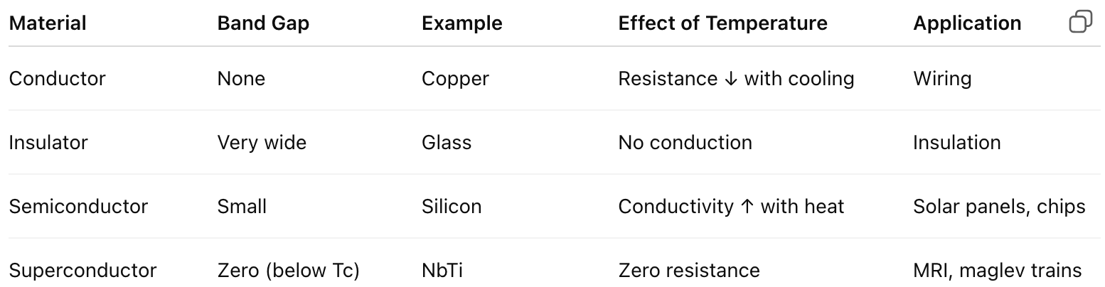 | -Teacher checks the completed table for accuracy.  -Groups swap tables and suggest corrections.
- FINAL EXPLANATION:  What will students be able to explain when they are finished with the Unit/Chapter?  Expectation for the final explanation: (citing evidence gathered that helps explain the scientific principles for this chapter/unit)?  Write out the final explanation here.  - Uses scientifically accurate and grade- appropriate scientific information to explain the phenomena | Revisit the Driving questions to identify what evidence students have gathered to help them answer the questions.  YouTube (Semiconductors & Applications): Here  Class posters and summary tables.  Introduction to Electronics – Final Explanation  Materials differ in their ability to conduct electricity, which is determined by their electrical properties. Conductors, such as copper and aluminum, allow electric current to flow easily because they have free electrons. Insulators, like rubber, plastic, and glass, resist the flow of current and are used to protect users and devices from electric shocks.  Semiconductors have conductivity between that of conductors and insulators. Their conductivity can be controlled through doping, which introduces impurities to create n-type or p-type semiconductors. This property allows semiconductors to control the flow of current in devices like solar panels, computer chips, and LEDs. Superconductors, on the other hand, conduct electricity with zero resistance at very low temperatures, enabling powerful applications such as MRI machines and high-efficiency magnets.  The flow of electricity in materials is affected by temperature: in conductors, resistance increases with heat, while in semiconductors, conductivity can increase. Understanding these properties allows engineers to design safe, efficient, and innovative devices that power modern life. Electronics are thus central to technology, renewable energy, and ICT, and studying them helps learners connect science principles to everyday applications. | What is the plan for helping students write this final explanation? (Use their final Model. Summary Table.)  Learners write their final explanation tying everything together:  - Define conductor, insulator, semiconductor, superconductor.  - Use band theory to explain differences.  - Describe temperature effects.  - Explain intrinsic vs. extrinsic, n-type vs. p-type.  - Relate to real-world devices (solar panels, chips, superconductors in MRI). | -Written test with rubric (accuracy, evidence, clarity, applications).  -Group oral presentations on real-life applications.  -Peer feedback on presentations.

CBE REQUIREMENTS REFERENCED IN THIS UNIT | Clearly articulate how these topics are addressed in this unit
Core competencies* (digital literacy, citizenship, learning to learn, collaboration/communication, critical thinking/problem solving, self-efficacy, imagination/creativity) addressed in this Curriculum Design | Core Competencies Developed (CCs):  - Communication & Collaboration – learners discuss in groups, share diagrams, and present findings on conductors, semiconductors, and superconductors.  - Critical Thinking & Problem Solving – learners interpret band diagrams, investigate how temperature affects conductivity, and explain intrinsic vs extrinsic semiconductors.  - Creativity & Imagination – learners design analogies (e.g., hurdles race for band gaps, party guests for doping) and use models to explain concepts.  - Digital Literacy – learners access PhET simulations and YouTube resources to visualize semiconductor behaviour.  - Self-efficacy – learners build confidence in applying electronics to real-life devices like phones and solar panels.  - Learning to Learn – learners develop strategies for researching modern electronics beyond the classroom.
Which Core Values** are addressed? (Nationalism and patriotism, Respect, Responsitillity, Integrity, Peace and Social Justice, Love, Unity, Excellence, Care and Compassion, Tolerance, Ethics) (do this by using Norms?) | Values Promoted:  - Responsibility – careful handling of electrical apparatus (wires, batteries, bulbs).  - Integrity – reporting experimental observations truthfully.  - Respect & Teamwork – respecting peers’ contributions during group experiments.  - Patriotism – valuing local applications of solar technology and ICT as part of national development.
Which pertinent and contemporary issues are/ or could be addressed in this scheme of work? | Pertinent and Contemporary Issues (PCIs):  - Environmental Conservation – semiconductors in renewable energy (solar).  - Technology & Innovation – ICT devices and microelectronics.  - Safety in Science – safe handling of electricity.  - Economic Development – link to manufacturing and Vision 2030.
Are there careers that might use this knowledge | Careers Related to This Unit:  - Electrical Engineer  - Electronics Engineer  - Renewable Energy Technician (solar, wind systems)  - ICT Specialist (computer hardware, phone repairs)  - Medical Physicist (MRI, imaging technologies)  - Research Scientist in Materials Science
Do we need to create Rubrics for any of the embedded assessments? If so list those here: | Rubrics for Embedded Assessments:  Rubrics can be created for:  - Energy Band Diagrams – accuracy of drawing, correct labeling, explanation of conduction.  - Group Presentations – clarity, teamwork, correct application examples, creativity.  - Summary Table (Conductors, Semiconductors, Insulators, Superconductors) – completeness, accuracy, ability to connect to real life.  - Final Explanation Essay – depth of understanding, use of scientific terms, application to real-world contexts.

*CORE COMPETENCIES:
- Communication and Collaboration:.
- Emphasizes the ability to effectively communicate ideas and work with others.
- Self-efficacy:.
- Focuses on building learners' confidence and belief in their ability to succeed.
- Critical Thinking and Problem Solving:.
- Encourages learners to analyze information, solve problems, and make informed decisions.
- Digital Literacy:.
- Develops the skills to effectively and safely use technology and digital tools.
- Learning to Learn:.
- Fosters a mindset of continuous learning and the ability to acquire new knowledge and skills independently.
- Citizenship:.
- Promotes an understanding of civic responsibilities and active participation in society.
- Creativity and Innovation: .
- Encourages learners to think creatively, generate new ideas, and find innovative solutions.

**CORE VALUES:
- Nationalism and Patriotism: Instilling a sense of national unity, identity, and pride in Kenya.
- Respect: Fostering respect for oneself, others, and cultural diversity.
- Responsibility: Developing a sense of responsibility towards oneself, the community, and the environment.
- Integrity: Promoting honesty, ethical behavior, and moral principles.
- Peace and Social Justice: Encouraging harmonious coexistence and equitable treatment of all.
- Love: Creating a supportive and caring learning environment.
- Unity: Promoting togetherness and social cohesion.
- Excellence: Striving for high standards in all endeavors.
- Care and Compassion: Developing empathy and concern for the well-being of others.
- Tolerance: Fostering understanding and acceptance of different perspectives.
- Ethics: Instilling a strong moral compass and ethical decision-making.

